Advanced RAG System Using Pinecone Vector Database and Groq LLM

Name: Irfan Shah
Course: Artificial Intelligence
Submission Type: Technical Report
Date:18/05/2026
______________________________________________________________________________
INTRODUCTION:
This project implements an advanced Retrieval-Augmented Generation (RAG) system that allows users to upload PDF documents and ask questions based on their content. The system retrieves relevant information using semantic search and generates accurate responses using a large language model (Groq).
The main objective of this system is to reduce hallucinations by ensuring that answers are strictly based on provided document context.

SYSTEM ARCHITECTURE:
The system follows a complete RAG pipeline:
PDF Upload → Text Extraction → Chunking → Embedding Generation → Pinecone Vector Database → Semantic Retrieval → LLM Response Generation → Final Answer Output
Each step ensures efficient processing and accurate retrieval of information.
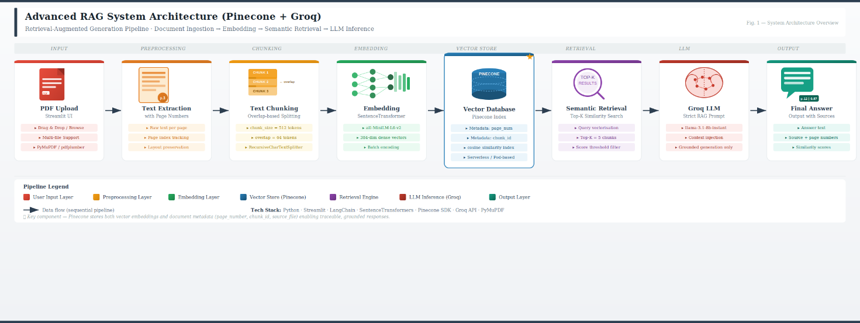
Figure: Architecture of Advanced RAG System using Pinecone and Groq.
IMPLEMENTATION DETAILS:
The system is built using Python and Streamlit. PDF files are processed using PyPDF, and text is divided into smaller chunks for better retrieval accuracy. SentenceTransformer is used to generate embeddings which are stored in Pinecone vector database along with metadata such as page number and chunk ID.
Groq LLM is used to generate answers strictly based on retrieved context.

TECHNOLOGIES USED:
Python
Streamlit
Pinecone Vector Database
Sentence Transformers
Groq API
PyPDF

CHALLENGES FACED:
During development, issues such as API timeout, large context handling, and model deprecation were encountered. These were resolved by optimizing chunk size, limiting retrieved context, and updating the Groq model.

RESULTS:
The system successfully retrieves relevant information from PDF documents and generates accurate answers with proper source attribution including page numbers and similarity scores.

CONCLUSION:
This project demonstrates a complete RAG system that integrates vector databases and large language models to provide context-aware and accurate responses.

FUTURE IMPROVEMENTS:
Multi-document support
Query history feature
Improved UI design
Faster embedding models
______________________________________________________________________________

